Task: Create a dashboard which lets you check the CPU utilization and networking for a particular EC2 instance.
Step1 : Firstly create 1 EC2 instance.
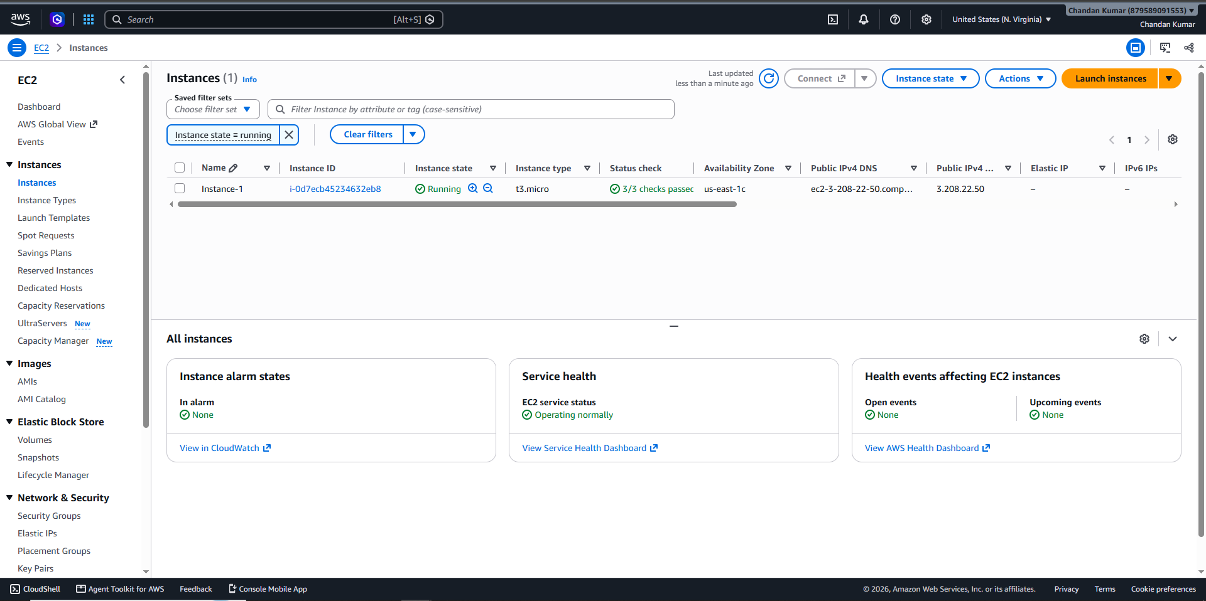
Step 2: Go to Cloud Watch > under cloud watch click on Dashboard > Click on create dashboard.
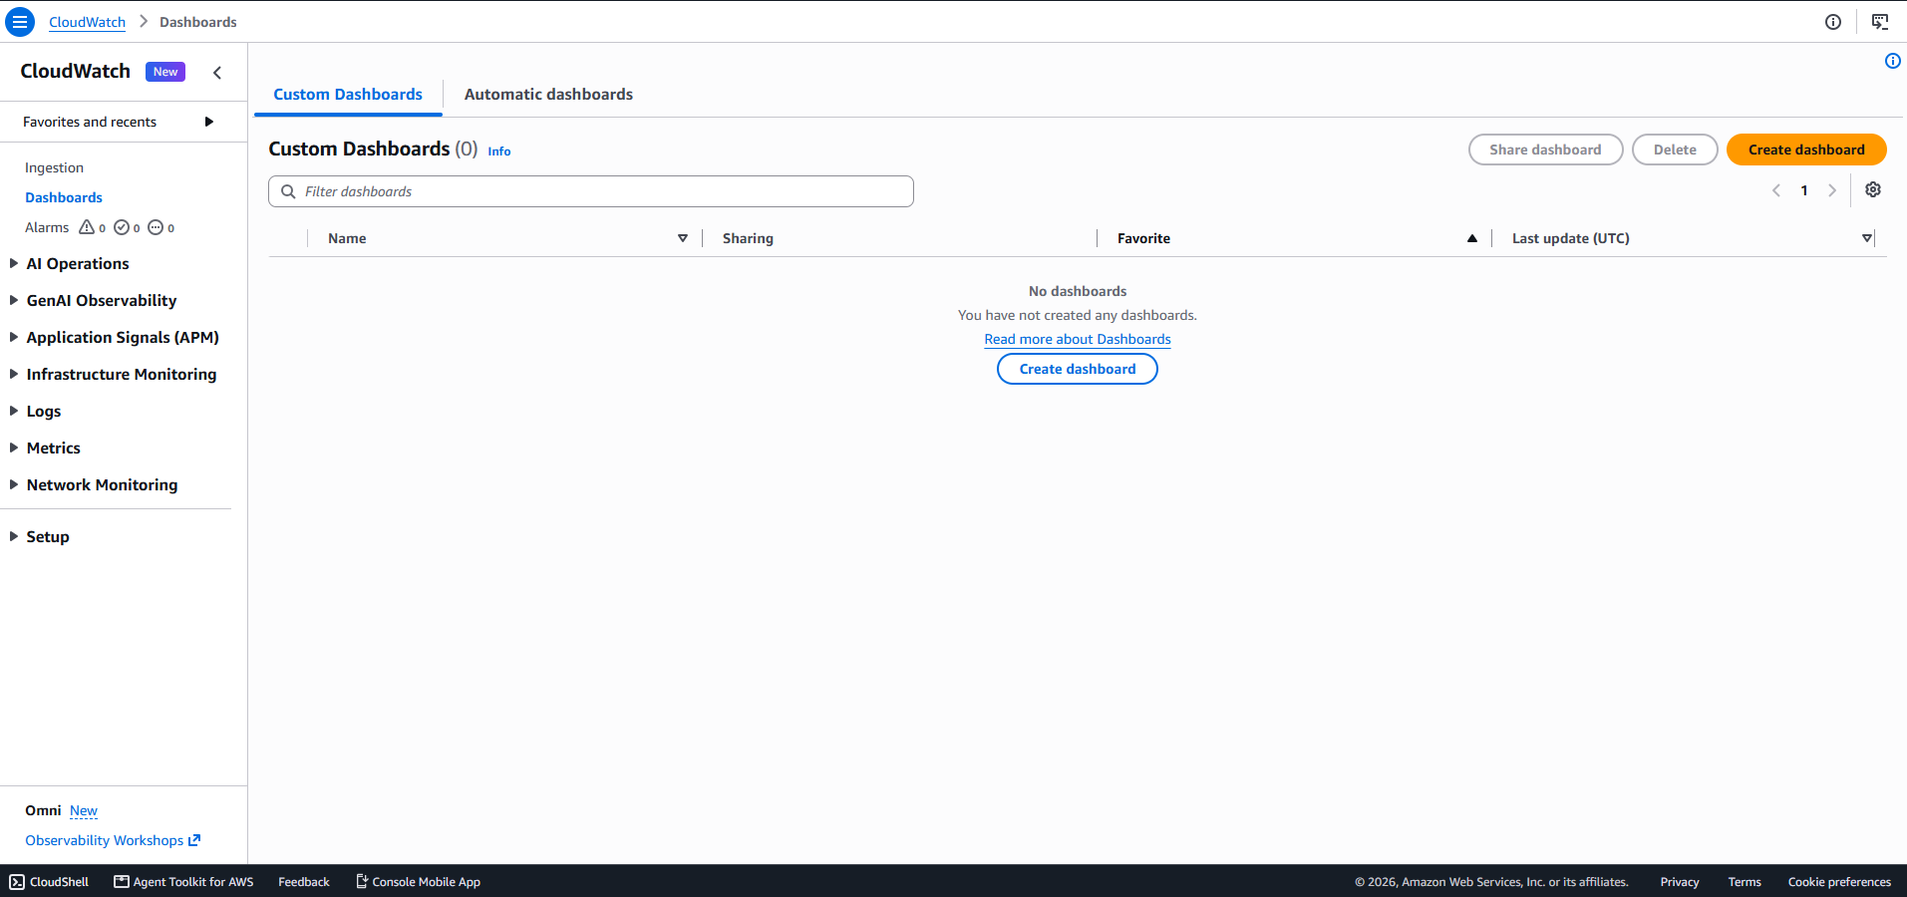
Step 3: Give Dashboard name= Instance_CPU_and_Network_Utilization > Click on Next > Select instance CPU utilization, Network In/Out > Click on create.


